# Idea

The theme of this story game is about the life cycle of the silkworm.

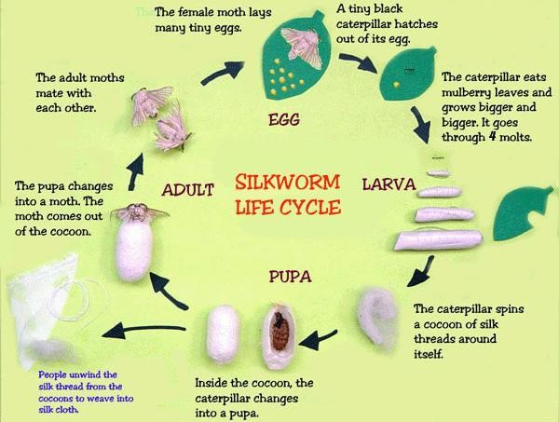

The total life cycle of a Silkworm ranges from 6-to 8 weeks. Generally, the warmer the weather, the quicker the Silkworm will complete its life cycle, however, other factors such as humidity and exposure to sunlight are also very important. Ideally, Silkworms will experience 12 hours of sunlight, and 12 hours of darkness per day, a temperature of 23-28 degrees Celsius, as well as humidity levels of 85-90%. Under these conditions, your eggs should hatch in 7-10 days.

## Eggs

In Australia, a Silkworm will naturally hatch in late July to early August – depending on the weather where you live – this time amazingly coincides with the Mulberry Tree regaining its leaves after the tree loses them in Winter. It is recommended that you store all of your eggs in a cold space (a fridge is ideal) because if there are fluctuations in the weather, your eggs may hatch earlier than expected. When placed in a cold area, we can control when our eggs hatch, therefore ensuring they will always have a food source. If our eggs have been placed in the fridge, they will begin developing and hatch after 10-25 days, depending on the warmth of the weather, with warmer weather causing quicker hatching.

## Larva/ Cocoon

After 20-33 days of constantly munching away at Mulberry leaves or chow, your Silkworm will feel the urge to cocoon. Lava that is ready to cocoon will be noticeable to the human eye, as they will appear translucent and yellowish. Just before it begins cocooning, the Silkworm will excrete a runny fluid to clean out its system and prepare it for the last stage of its life cycle. It will then ooze a tiny drop of Silk for anchoring, before going on to draw one long, continuous filament of Silk by swinging its head to-and-fro. This process can take up to 48 hours for the Silkworm to fully complete, and the result will be a perfectly ovate cocoon, with one continuous strand of silk up to 1 kilometer long! Inside the cocoon, the Silkworm will molt for the last time, as it approaches the last stage of its life cycle to become a moth. Sometimes Silkworms do funny things, and this is evident when a Silkworm decides to spin a cocoon with a friend. When this happens, the cocoon will be noticeably larger, however, if the two are members of the opposite sex, sometimes the cocoon does not hatch, and we will open it to find two dead Silk-Moths and a bunch of eggs inside the cocoon!

# Moth

After 10-14 days of developing into a moth in its cocoon, the Silk-Moth will appear from the cocoon and will excrete a brownish fluid upon emergence – don’t worry, this is completely normal, and is a sign the Silk Moth is cleaning out its system.

Silk-Moths cannot fly, as a result of thousands of years of domestication, however male Silk-Moths may leave their container/shoebox as they search for a female mate. Some males may be able to almost fly if you drop the from a small height, however it is uncontrolled, and they will hit the ground after a few moments.

It is quite easy to separate the male and female Silk-Moths, with the females having larger abdomens and males possessing smaller abdomens. Males also tend to be more active, as they are constantly searching for a mate. The moth lives a very brief life of 5-10 days, with males generally living longer than Females. Silk-Moths will begin to search for a mate almost immediately after emerging from their cocoon, with some seen mating with a moth of the opposite sex inside their cocoon should two moths share one! After mating, the Female Moth will lay between 300-500 eggs, and die, whereas the male Silk-Moth will search for another mate, should it not be too old.

<https://youtu.be/bvLghveYDIk>

<https://youtu.be/8DzGXGBhF-U>

## Game Story Part-1:

In native northern China, where lots of silk moth lives there was a male silk moth named Li Yun and a female silk moth Zhang Yi. Li Yun was traveling in the mulberry forest searching for food when he suddenly meets Zhang Yi. Her prettiness attracts him and then both of them fell in love with each other.

In early summer, Zhang Yi laid eggs (centrolecithal eggs) on mulberry leaves. She lays 300-500 eggs colored lemon yellow. The egg will go throw rain and wind and some of them even get destroyed. 100 eggs survived and after 7 to 20 days the egg got hatched and turned into a grey color. Ni Yun and his siblings were born from those eggs. Now, little Ni Yun is ready to go out and have fun in the mulberry forest.

## Playing part 1:

A playable game world is created where Ni Yun in caterpillar form will be playable.

## Game Story Part-2

After eating some mulberry leaves, Ni Yun will see the signboard drawn by one of his kind. He sees it and immediately remembers the flashback where one of the old caterpillars (Zhu Shin) gives his sibling and him a lesson about making the signboard in case they get lost. Master Zhu Shin also told them to look for the lost caterpillar if they ever see that sign.

Ni Yun found his three siblings Ying Yun, Ming Yun, and Xin Yun, and asked them to help that lost caterpillar but they told him it was someone trying to prank. They made fun of him and tell him that he is too credulous and dumb that he couldn’t know that it was a prank. Ni Yun and his three siblings argued against it and his siblings refused to go with him. Ni Yun told them he is not dumb and credulous, it was just what if that caterpillar needs help and what if something bad happened to that caterpillar if that caterpillar is not rescued. After hearing that his three siblings still made fun of him, laughed at him and told him to go alone if he wants to. Ni Yun said to them, “You will never know if you don’t try” and went towards the direction of the board searching for the lost one.

## Playing Part 2

In this game, Ni Yun have to doze the bird and fight the ant to reach the destination

To jump to the other side Ni Yun have to roll on and hit the leaf to get spring jump to the other side

## Game Story Part 3

Ni Yun heard the sound of someone crying and he move towards that sound. He saw his sister Mei Yun crying. He went towards and said Hey Mei it’s all right, your brother is here now. He told her not to worry and comfort her. Mei Yun stopped crying. Ni Yun told her that he will show her way back to the mulberry forest and try to stick with him because it’s too dangerous out there. She thanked Ni Yun for coming to help her. Ni Yun told her that its brother's duty to protect his sister and both of them went towards the mulberry forest.

### Playing Part 3

The gameplay of the part is the same as part 2. Ni Yun will be in front of Mei Yun and Mei Yun will be following the Ni Yun. When the birds' attack Ni Yun will use the leaf as a shield for him and his sister. Ni Yun will clear the path for Mei Yun in this game.

## Game Story Part 4:

Ni Yun and Mei Yun reach back to their caterpillar group at mulberry forest. Days passed by and it was the 20th day of being a caterpillar for Ni Yun and he wasn’t ready to be a pupa and wasn’t ready to produce silk for the cocoon. His all siblings were ready for the pupa phase. He heard some of his siblings saying that Ni Yun is not going to be able to morph into a beautiful moth. Ni Yun heard them making fun of him.

Ni Yun felt bad from hearing those words from his siblings. He gave a thought about it and felt bad. He talked with himself saying that all of them are ready to morph into pupa but only I’m not ready. He was very sad and went into the inner forest. He got attacked by an ant in the forest and he had no choice but to fight back.

## Playing Part 4

In the first phase, he will fight 10 ants one by one and after he will fight 2 ants at a time for 3 times

The main boss ant will appear after the first phase is completed. The main boss ant will come with his 3 little ants

The part will be over when Li Yun will kill three little ants and make the hp of the main boss 25 % and after that, he will be knocked back by the boss ant.

## Game Story Part 5

After getting knocked back by the boss and the boss will try to bite the Li Yun but right at the moment Fen Hua attacked the ant from the back and knock it down. Then, she introduced herself to Li Yun and Li Yun also introduce himself to her. Fen Hua asked him what he was doing in the inner forest, then Li Yun explains everything and told her that he can never be a moth. Then, Fen Hua laughed at him. Li Yun gets offended and her why are you laughing then she will explain the life phase of the caterpillar to him and that some may be able to morph earlier and some may take more days, 20-33 days. So, there’s nothing to worry about and he can be morph into a beautiful moth and she encourages him that he can also be a beautiful moth.

Ni Yun thanks her for saving his life and also for encouraging him. He also asked her how he can pay back her for saving his life. Fen Hua just smiled and tell that he doesn’t have to pay her back. Two became a good friends and walk into their respective bases.

The next day, they both went on a walk together. On their way, they saw humans stealing the eggs of the Silkmoth from another base. Ni Yun asked Fen Hua why humans were stealing those eggs. Then, Fen Hua explains to him about the silk that they produce in their pupa phase is useful to humans. And also, explain how humans extract the silk from cocoons. Ni Yun got terrified after hearing that.

On the 32nd day of being a caterpillar, Ni Yun was finally ready to morph into pupa and produce silk. He meets Fen Hua and say her that he is ready to morph into a pupa and she told him the same. Then, Fen Hua comes into the forest where they meet for the first time after turning into a silk moth. Ni Yuan agree on that and then both went on their bases to morph into a pupa.

Playing part 5:

Ni Yun has to build a cocoon in this part. The arrow will appear on the screen and the player have to press the arrow before it disappears. Players have to do this until the cocoon is completed.

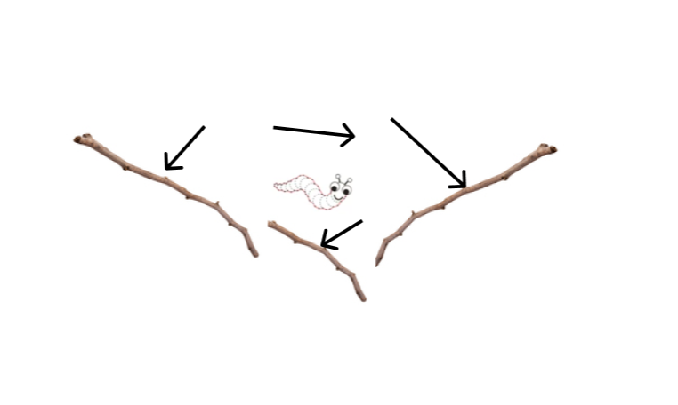

# Story Part 6:

Ni Yun developed a cocoon around him in 3 days and morph into a beautiful moth on the 12th day. He became so happy after being morphed into a beautiful silk moth. He remembered his promise to Fen Hua and went into the forest (at the spot where they met at first). He saw that Fen Hua was inside the glass jar. She got captured by the group of lepidopterists (person who catches moth and study moth). Ni Yun took a deep breath and went to save her. The slapped his wings and put the dust into the eyes of the lepidopterist who was holding the jar where Fen Hua was kept. The Lepidopterist dropped the jar and Fen Hua was free. But now they have to escape the group of Lepidopterists.

# Playing part 6

Top to a bottom world where players have to dodge the net.

## Story Part 7:

Ni Yun and Fen Hua finally escaped lepidopterists and went back to the mulberry forest. Fen Hua thank Ni Yun for saving her life. Fen Hua said that he has become a beautiful moth. Ni Yun said to her that she has also become a beautiful moth and maybe the prettiest moth. Fen Hua smiled at Ni Yun and told Ni Yun that she likes him and want him to be her mate partner. Ni Yun also told her that he likes her too and agree to be her mate partner. They happily spend the rest of their lives together.